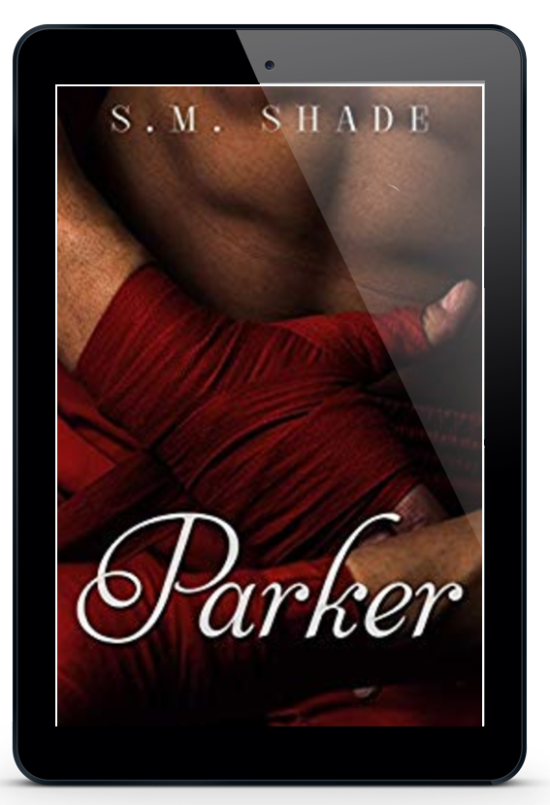

Title: Parker
Series: Striking Back
Author: S.M. Shade
Genre: Contemporary Romance
Publication Date: November 13, 2015
ISBN-13: 9781519799678
ISBN-10: 1519799675

Hit it and quit it.
One and done.
Hump and dump.

That has been my philosophy on relationships for the last seven years. Don't get me wrong, I'm not a bad guy. I'm always upfront and truthful with the women I date. I don't promise them anything but a good time.
I could've gone on happily sleeping my way through the major metropolitan area if it wasn't for her. The dark haired beauty who haunts my days and keeps me awake at night. Strong and sweet, she makes me reconsider everything I believe about love.

Too bad she's completely off limits.

I've never been good at following the rules.
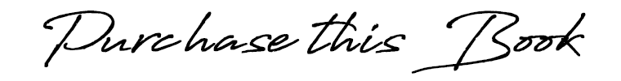

Amazon US ➼ https://amzn.to/2CdYvcc
Amazon CA ➼ https://amzn.to/2Ccf74e
Amazon UK ➼ https://amzn.to/2PtSCeR
Amazon AU ➼ https://amzn.to/2yg6EtU

Add to Goodreads ➼ http://bit.ly/ParkerGR
Add to Bookbub ➼ http://bit.ly/ParkerBB

His fingers slide beneath my chin and he tilts my head up. Our faces are so close, his breath warms my lips, and my heart rate leaps forward. “You always make my day better,” he whispers before closing the gap and pressing his lips to mine in a soft kiss.

I swear I evolved on this earth just to kiss this man. It’s a long searching kiss that makes every inch of my skin tingle. His eyes lock on mine when we break apart. “We’re going to happen, doll.
Not here and not like this, but I won’t fight it anymore. Life’s too short not to be with the people you care about.”

Mason’s bed is empty when I wake, but I can smell Parker’s scent on the sheets. The memory of the night before seems like a dream, his soft kisses and affectionate words.
For the first time in six weeks, I’m not dreading the future. Parker has feelings for me. Maybe our timing isn’t the greatest, but it won’t stop us from seeing where this could go. Does he want a relationship? Parker is a notorious playboy. Is it naïve or narcissistic to think he’ll change for me?

