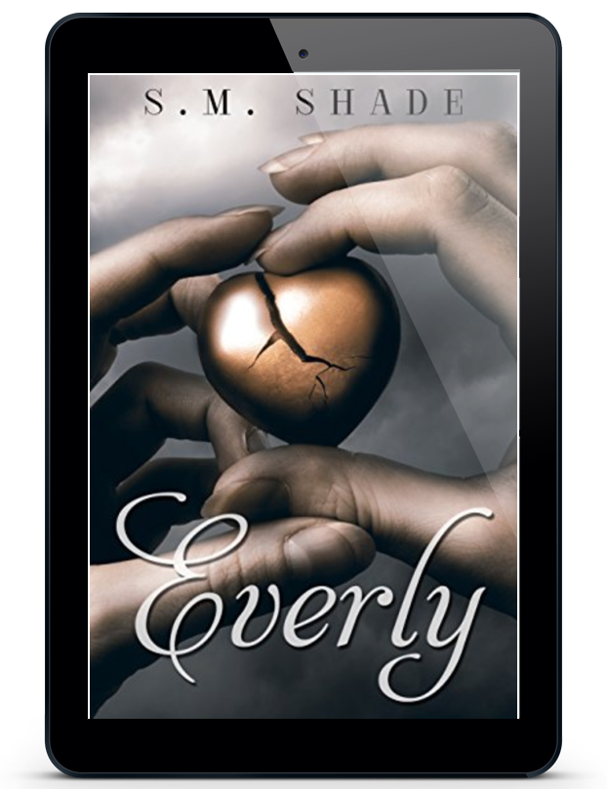

Title: Everly
Series: Striking Back
Author: S.M. Shade
Genre: Contemporary Romance
Publication Date: April 16, 2015
ISBN-13: 9781516919994
ISBN-10: 1516919998

The first time I met Mason Reed, we were standing naked in a bank, surrounded by guns.

That should have been a warning.

An MMA champion, trainer, and philanthropist, but not a man who gives up easily, Mason is trouble dipped in ink and covered in muscle.

Growing up in foster care, I'm well aware that relationships are temporary, and I do my best to avoid them. After a sheet clenching one night stand, I'm happy to move on, but Mason pursues me relentlessly. Sweet, caring, protective, and at times, a bossy control freak, this persistent man has climbed inside my heart, and I can’t seem to shake him.

After saving me from a life threatening situation, he’s also won something much harder to obtain. My trust. But does he deserve it? Is his true face the one he shows the world? Or is his charitable, loving manner only a thin veneer?

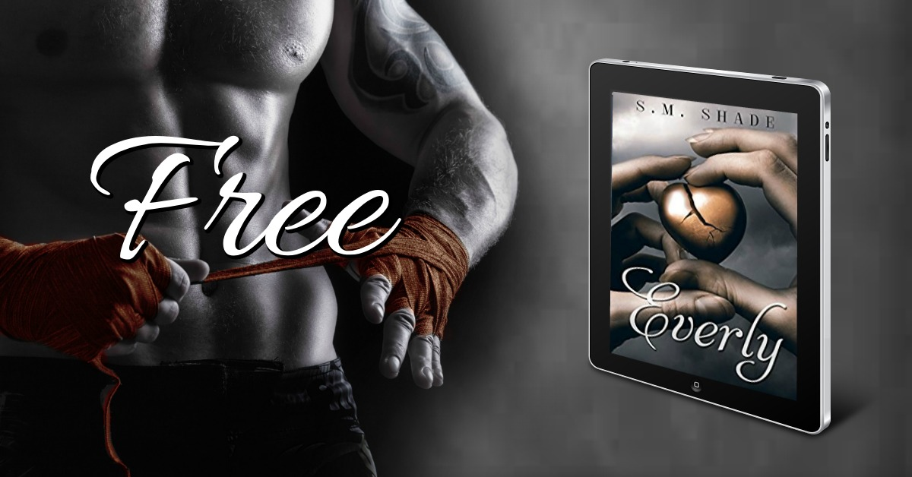
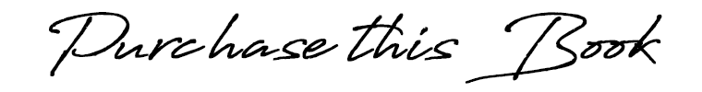

Amazon US ➼ https://amzn.to/2DyJ2pz
Amazon CA ➼ https://amzn.to/2R5fSB5
Amazon UK ➼ https://amzn.to/2R2xjSZ
Amazon AU ➼ https://amzn.to/2zBDh6n
Ibooks ➼ http://bit.ly/EverlyIbooks
B&N ➼ http://bit.ly/EverlyBN
Kobo ➼ http://bit.ly/EverlyKobo

Add to Goodreads ➼ http://bit.ly/EverlyGR
Add to Bookbub ➼ http://bit.ly/EverlyBookBub

“You never give up, do you? Luckily, I think I’ve found you a date.” I point to the tabletop where someone has scratched the words ‘Tanya gives good head’ deep into the wood. “She apparently performs oral well. I could write down the number for you.”

Shaking his head, his amused eyes meet mine. “I won fair and square. You owe me. Are you reneging on our bet? You seemed more honorable. I’m truly disappointed, Evie.”

Oh shit. We’re eating lunch together. The bastard is smooth. “This isn’t a lunch date!”

“A picnic lunch beside a babbling brook? This is the ultimate lunch date, baby.”

Ugh. This man is so frustrating! I ball up my trash, avoiding his gaze. “You tricked me.”

“I don’t remember getting any guidelines or rules. I got a lunch date with you. I win. We’re going to the carnival together.” A wide smile spreads across his face. Smug bastard.

“We’re not.”

“And then I’m taking you out to dinner.”

“You don’t understand the word ‘No’ do you?”

“Nothing wrong with my comprehension, love. Those gorgeous lips keep saying no, but those soft brown eyes are begging me not to give up.”

“I’m not going to fuck you.” That should send him running.

“I imagine the restaurant I have in mind would frown on that.”

“I’m serious. I’m sure this approach normally works for you. That you can flash those baby blues, flex your muscles, and order girls into your bed. I’m telling you now, you have the wrong person. Stop wasting your time.”

His rough hands catch mine, and he looks into my eyes. “Time is all we have, and there’s never enough. Not a second spent with you would be a waste of time, Everly.”

God, what his voice does to my name. “You only want me because I’m saying no.”

“You’re only saying no because you want me.”

“You’re deluded.”

“You’re beautiful. Now grab your trash. I can’t date a litterbug.”

