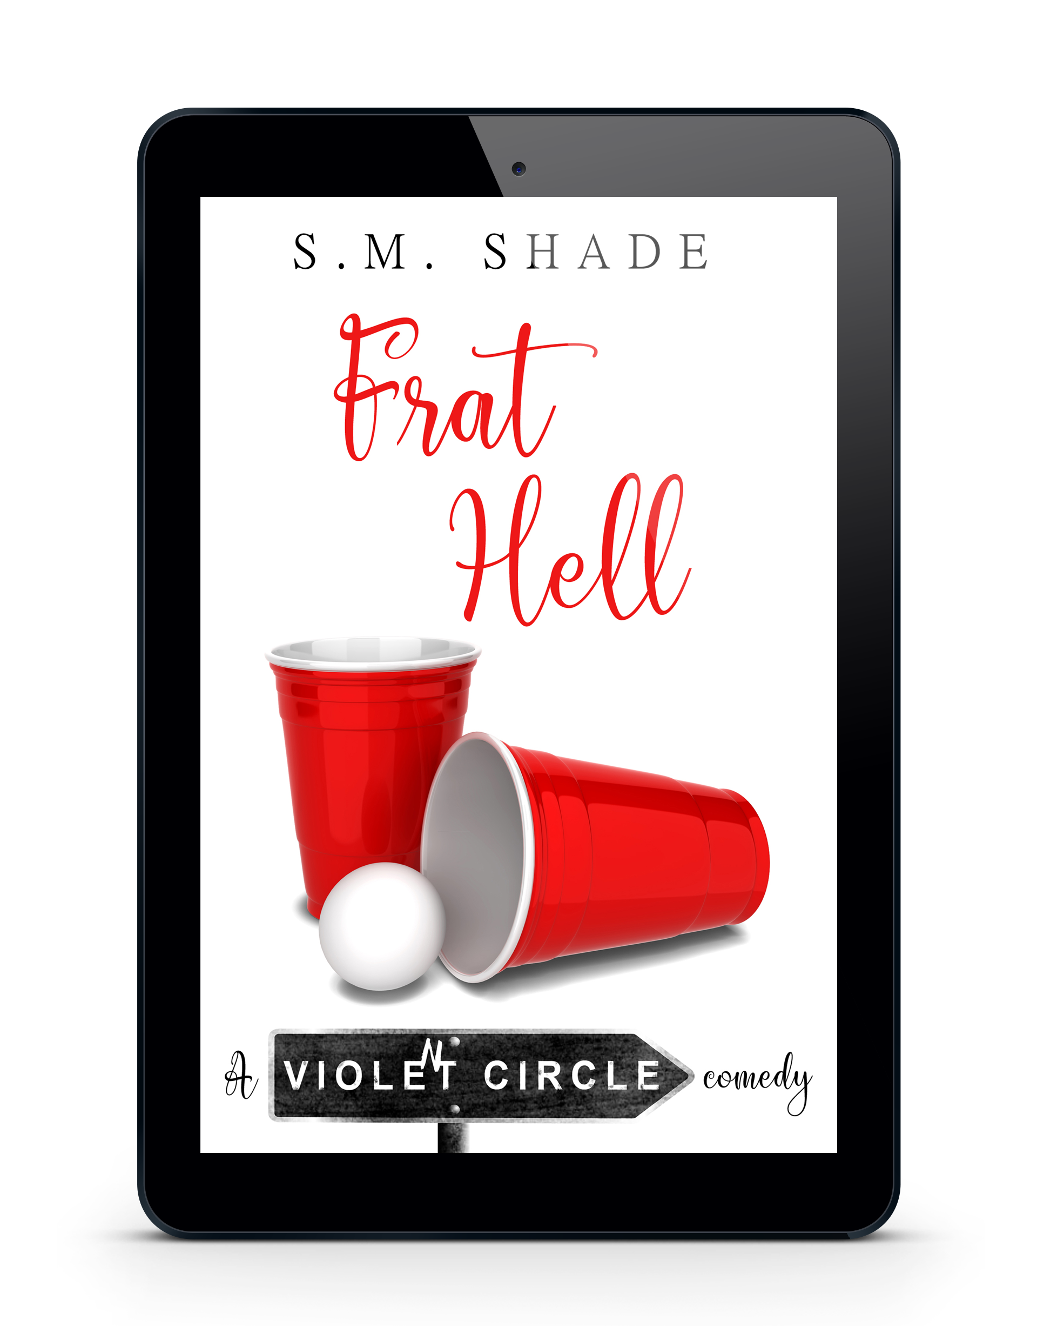

Title: Frat Hell
Series: Violent Circle
Author: S.M. Shade
Genre: Romantic Comedy
Publication Date: February 27, 2018
ISBN-13: 9781722716370
ISBN-10: 1722716371

Frat Hell.
​
That’s how the whole neighborhood refers to the apartment where I live with three other college students. It’s a bit judgmental, considering the neighborhood we live in is more like a zoo than an apartment complex, but not inaccurate. If you put that many young guys together, things are bound to be interesting. I still maintain that the giant water guns filled with poison ivy water were not my idea.
​
January Dixon.
​
She’s the girl I’ve lusted after for years. A smart mouth and sharp tongue surrounded by soft beauty and a body I’d give up an organ just to touch. An important organ, like a kidney, not one of those lame ones like a gallbladder.
​
It’s a tricky situation since she lives right down the street, and dating a neighbor generally isn’t a good idea. But this is Violent Circle, where normal may as well be a dirty word. Thanks to an impromptu fashion show where I tossed all self-respect aside and strutted my stuff in full bondage gear in front of our small town, she now owes me a date.
​​
And I plan to collect.

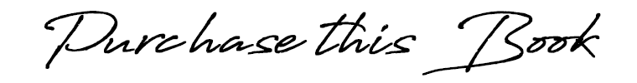

Amazon US ➼ http://amzn.to/2CFYF94
Amazon CA ➼ http://amzn.to/2HIHabK
Amazon UK ➼ http://amzn.to/2F36P09
Amazon AU ➼ https://amzn.to/2OpE8jG

Add to Goodreads ➼ http://bit.ly/FratHellGR
Add to Bookbub ➼ http://bit.ly/FratHellBB

He grabs my hand and we start making our way back up the path. It’s less of a path and more of a mudslide now that the rain has started.

Laughing, we slip and slide until get about halfway up. My foot slides, but I manage to catch it on a root, and brace my hand against a tree. Noble isn’t so lucky. The soft earth gives way beneath his feet, and a small yelp leaps from his mouth before he goes tumbling back down the slope.

Tumbling isn’t the right word. The three backward somersaults he manages on the way down would be impressive if he were trying to do them. He finally stops himself, and lies back in the mud. Trying my best not to laugh—damn what I would give to have that on video—I rush back down to check on him.

“Noble? Are you okay?” Shit. What if he broke his neck and I’m standing here laughing at him?

Staring up at me with a straight face, he says, “I think I saw my own ass crack.”

“I don’t think that’s physically possible,” I laugh, kneeling beside him.

“Neither did I. But I swear I mooned myself.”

“Are you hurt?”

“Nope, just waiting on the judge’s score. You saw that shit, right?” His cheeks redden, and I realize he’s embarrassed. Ugh, why does he have to be so adorable?

“It was a solid eight.”

“Only eight?” He starts to sit up, but I push him back and stop his next words with my lips. This kiss isn’t as soft and gentle as the last one. His hand grips the back of my head, and he moans as I slip my tongue between his lips. The cold mud seeping through our clothes and the icy rain falling on us is no match for the heat that washes over me when he brushes my tongue with his.

“Are you trying to kiss it better?” he asks when we break apart.

“Did it help?”

I grab his hand, and he gets to his feet. “Absolutely. I’ll do a swan dive into the mud if that’s my reward.”

