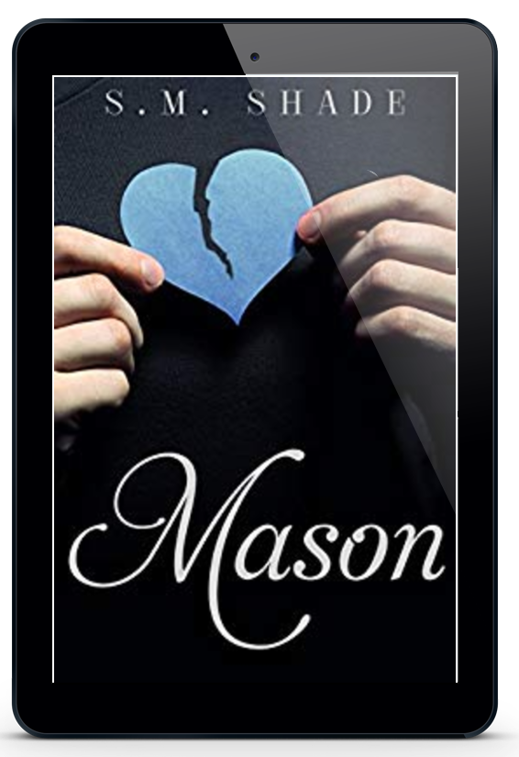

Title: Mason
Series: Striking Back
Author: S.M. Shade
Genre: Contemporary Romance
Publication Date: July 3, 2015
ISBN-13: 9781516920167
ISBN-10: 1516920163

From the moment I saw her, I wanted her in my bed.

I should've stopped there.

Everly Hall burst into my complicated life and changed it forever. I'm a fighter, but I had no defense against this beautiful, stubborn woman.
Now, I stand to lose everything I have, everything I am. My secrets are dangerous, and put more lives at stake than my own. I intended to tell her in time, but my time is up.

Everything rests on Everly.

This is the conclusion of Mason and Everly's story.

Contains violence and sexual situations and is intended for adults 18 and older.

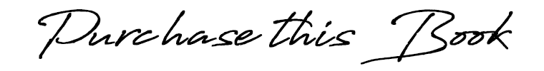

Amazon US ➼ https://amzn.to/2pSzKuE
Amazon CA ➼ https://amzn.to/2RPEI8D
Amazon UK ➼ https://amzn.to/2OlBXxA
Amazon AU ➼ https://amzn.to/2RL8KKv

Add to Goodreads ➼ http://bit.ly/MasonGR
Add to Bookbub ➼ http://bit.ly/MasonSBBB

“We need a proposal story I can actually tell people,” Evie complains, grinning at me. “It’s bad enough the story of how we met includes us being naked.”

“Tell them the truth.”

“I’m not saying you proposed with your face in my crotch.”

“Like you said, baby. We met naked. I think it fits us perfectly.” I pull my shirt over my head while she rolls her eyes at me. “We can take the bandages off our tats,” I remind her as she strips off her tank top and shorts.

“You first,” she replies with a smirk.

“No way, baby. I can’t wait any longer to see what means enough to you to permanently mark your beautiful skin.”

I’m rewarded with a soft smile. “Okay.” She bites her lip when I kneel and slowly remove the gauze. It’s not the sight of the bright yellow daisy that stuns me, but the script beneath it that spells my name. My name permanently etched on her soft skin.

“In Norse mythology, daisies represent love and fertility. Sensuality and motherhood.” Her eyes tear and her hand tightens in my hair. “You’ve given me all those things.”
I rest my forehead against her bare belly, trying to get a grip on my roiling emotions. I’ve chased this woman until I was half crazy and even when I caught her, I could never be sure she loved me like I do her. But she does. She does.

“Do you like it?” she asks softly.

“Sweetheart, there are no words.”

