Title: Tucker
Series: In Safe Hands
Author: S.M. Shade
Genre: Contemporary Romance
Publication Date: July 30, 2017
ISBN-13: 9781978028456
ISBN-10: 1978028458

Tucker

She’s beautiful.
She’s young.
She’s driving me out of my mind.
I’ve always done my best to avoid Leah Bolt. I have enough problems without having to deal with a young woman with a crush. My life has been a disaster since I was court-martialed and dishonorably discharged from the military. After spending a year living on the streets, I’m finally starting to pull things together.
Now, I’m stuck with her, living side by side in my house with my complete opposite. If spending every day with this peppy, optimistic, energetic woman doesn’t kill me, her brother will. Dare is a friend and a member of In Safe Hands, a group that tracks down sexual predators and brings them to justice. He has also done time and is the size of a mountain.
I’ve survived combat, but I may be taken down by a perky blond.

Leah

He’s gorgeous.
He’s older.
He’s a stubborn, broody jerk.
Tucker Long is every woman’s dream…until you talk to him. He may be sexy when he’s out sweating in the sun with sawdust clinging to him as he hammers and saws, but try to hold a conversation and all you get are grunts and nods.
He was the one who wanted a house sitter and just because his plans fell through doesn’t mean I’m changing mine. My future is up in the air while I try to decide who I want to be, and Tucker’s farm is the perfect place for me to do it. He calls me kid, but the way he looks at me doesn’t lie.
I may be ten years younger, but I can still handle him.

Amazon US ➼ https://amzn.to/2CJE48m
Amazon CA ➼ https://amzn.to/2NIpkrc
Amazon UK ➼ https://amzn.to/2PzwD6f
Amazon AU ➼ https://amzn.to/2CfUCUf

Add to Goodreads ➼ http://bit.ly/TuckerGR
Add to Bookbub ➼ http://bit.ly/TuckerBB

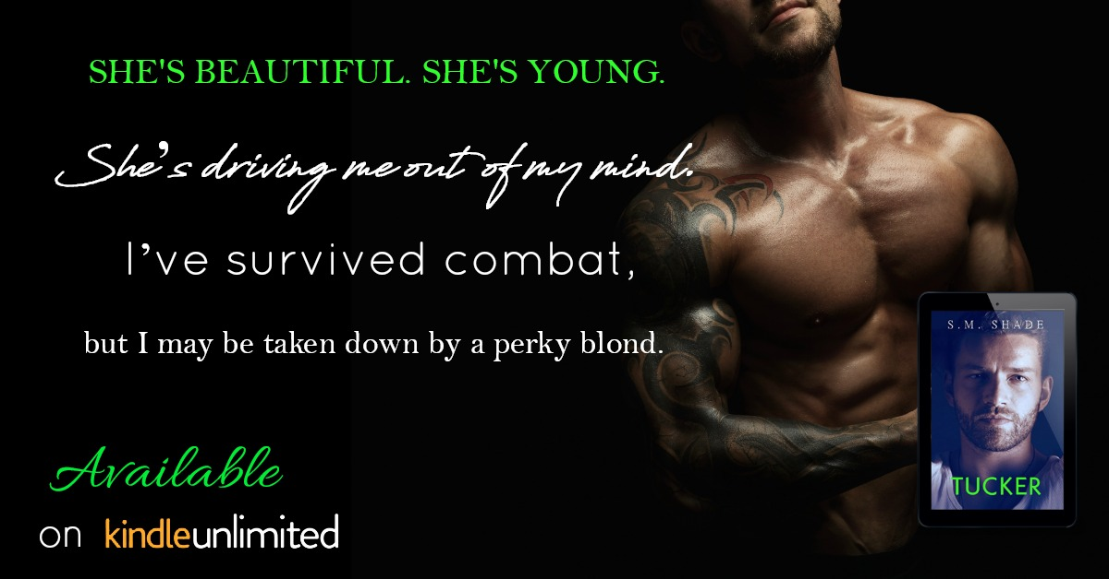

“So,” she chirps, hopping into the truck. “Where do you want to eat?”

Damn. I did say I’d grab something in town, but that wasn’t a dinner invitation. “Have you tried that little

Mexican place? I love tacos,” she goes on. “But if you’d rather have—

“Tacos are good.” I park at the small restaurant, and she hops out of the truck again.

“Are you laughing at me?” she asks, noticing the smirk on my face. I can’t help it. She’s like a sugared up toddler.

“Just admiring your energy level,” I tease. “Come on, kid.”

“I’m not a kid!”

“Uh-huh.” Seconds after we’re seated in a booth, a waitress takes our order, and we’re left alone. I try to ignore the awkward silence by playing with my phone, but she’s having none of it.

“So, you work for Striking Back now?” she asks, sitting back and sipping her drink.

“Sometimes. When they need me.”

“And you build stuff?”

“Yep.” Still looking at my phone, and not really paying attention.

“And whore yourself out on the weekends?”

“Uh-hu—what?” My head jerks up, and she dissolves into giggles.

“Hi, welcome to the conversation. I’m Leah, the human seated across from you, and you are?”

My lips twitch up. “In for a long six months it seems.”

